|  |  |
| --- | --- |
| Student Name | Mohit Mukesh Patel |
| SRN No | 202200749 |
| Roll No | 53 |
| Program | Computer Engineering |
| Year | Third Year |
| Division | B |
| Subject | Computer Network Laboratory (BTECCE22506) |
| Assignment No | Two |

Assignment Number - 02

**Title :** Study of Linux and Windows Network commands

**Problem Statement** Studying Linux and Windows network commands. [ ping, pathping, ipconfig/ifconfig, arp, netstat, nbtstat, nslookup, route, traceroute/tracert, nmap, etc]

**Try to execute following commands on linux terminal or Windows command prompt.**

* + **Ipconfig / ifconfig**
  + **ping**
  + **Tracert/Traceroute/Tracepath**
  + **Finger**
  + **NSlookup**
  + **Netstat**
  + **Hostname**
  + **Port Scan / nmap**
  + **Arp Route**
  + **Whois**

**Theory :**

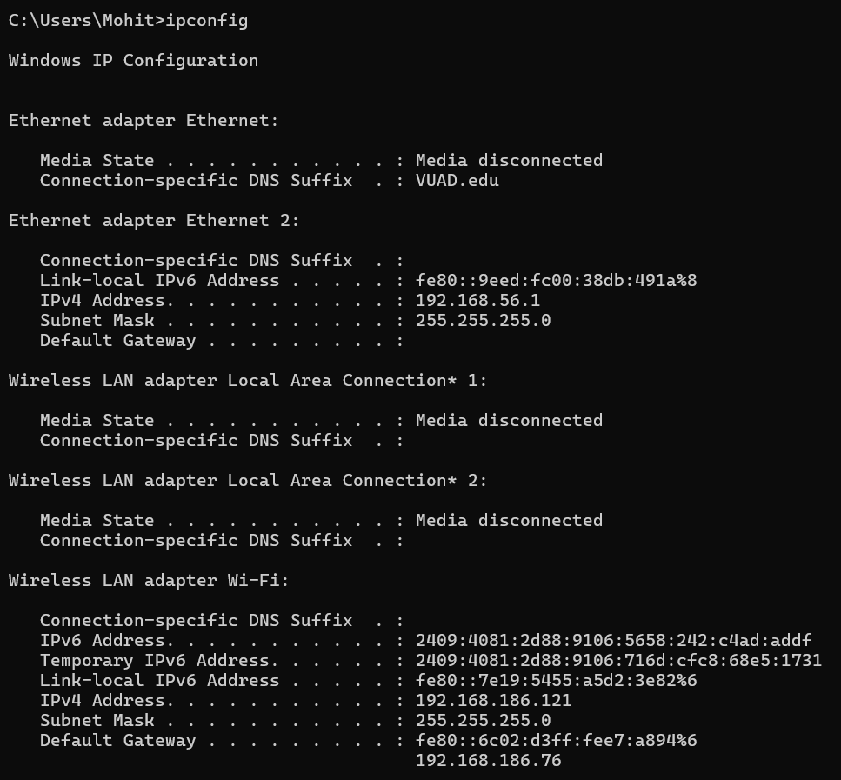

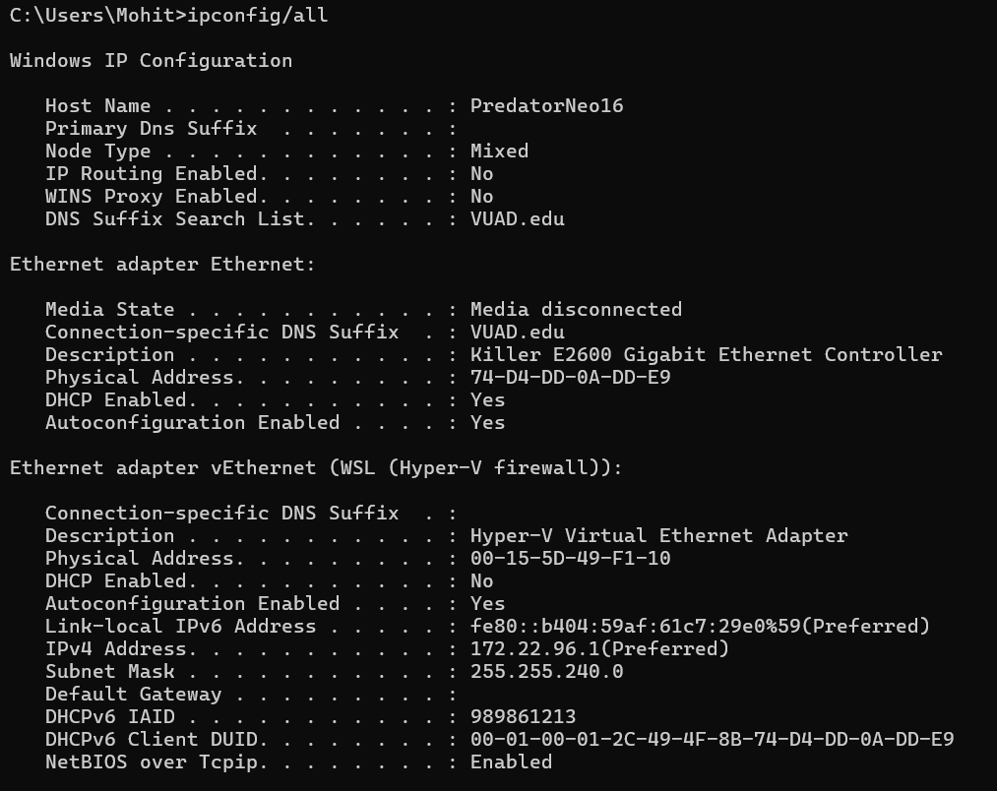

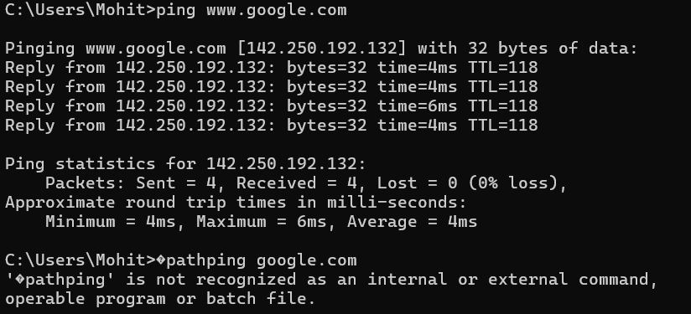

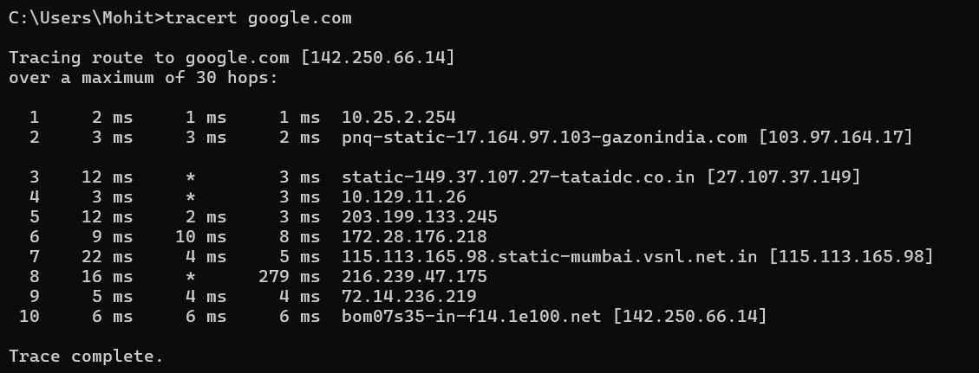

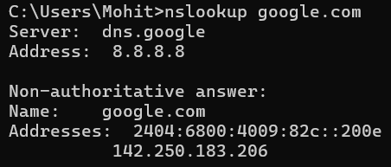

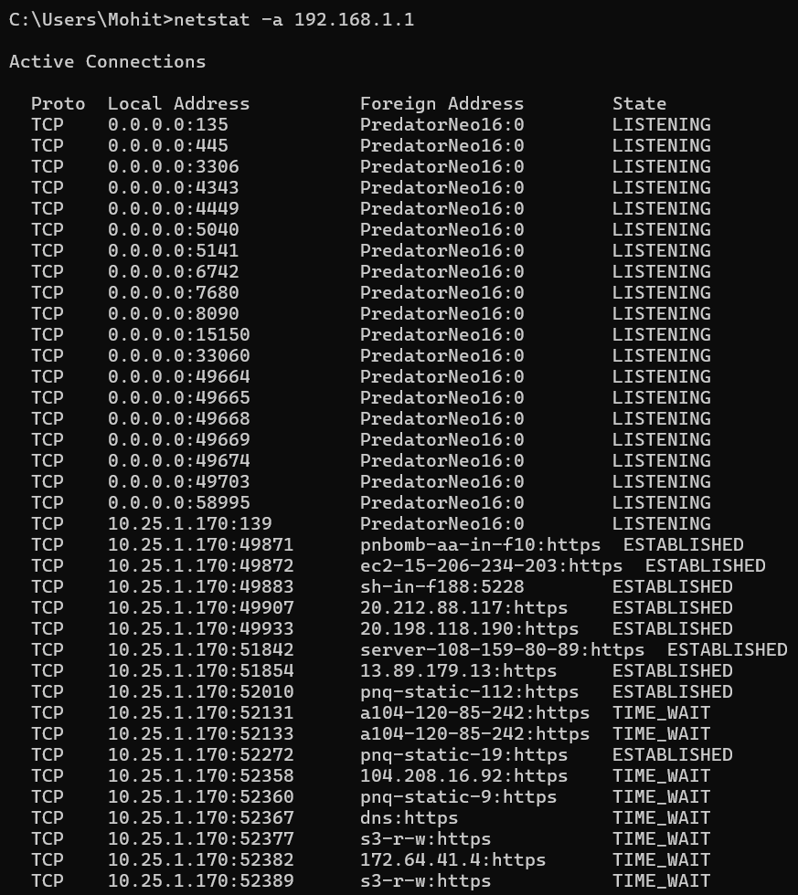



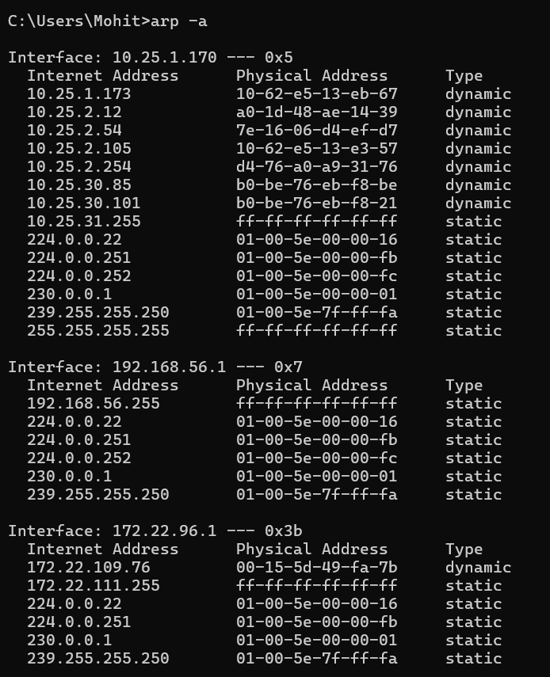

**Conclusion :**

**In conclusion, the study of Linux and Windows network commands provides essential insights into the tools available for network troubleshooting and diagnostics. By executing commands like ipconfig/ifconfig, ping, tracert/traceroute, and others, we gain a practical understanding of network configurations, connectivity, and security analysis. These commands are crucial for system administrators and network engineers to monitor, maintain, and secure network infrastructure. Mastering these tools equips us with the ability to diagnose and resolve network issues efficiently across different operating systems. This exercise underscores the importance of a strong foundational knowledge of network commands in both Linux and Windows environments.**